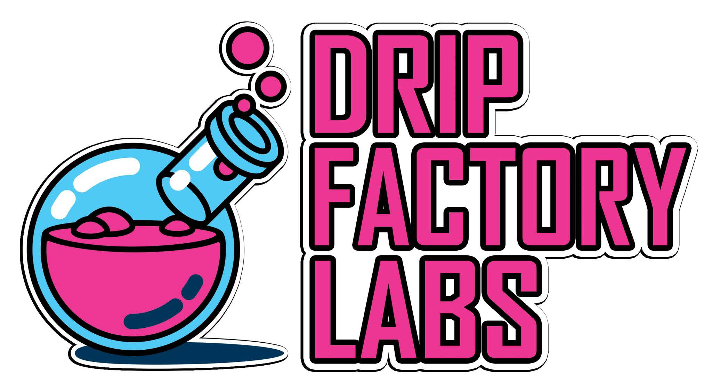

CERTIFICATION OF COMPLIANCE IDENTIFICATION of the PRODUCT COVERED by this CERTIFICATE:

CRC DROPPER & BOTTLE GCC

CERTIFICATION OF COMPLIANCE
IDENTIFICATION of the PRODUCT COVERED by this CERTIFICATE:
CRC DROPPER & BOTTLE
- Citation to each CPSC product safety regulation to which this product is being certified: 1700.15 of title 16 Code of Federal Regulations as determined through testing in accordance with the method described in section 1700.20 of title 16, Code of Federal Regulations.

- Identification of the product covered by this certificate: Drip Factory Labs: The Lab Collection

FROOTZ-
MONSTER SNOT 15ml,30ml,120ml (0mg, 1.5mg, 3mg, 6mg, 12mg, 18mg)
BEOWULF 15ml,30ml,120ml (0mg, 1.5mg, 3mg, 6mg, 12mg, 18mg)
BEETLE JUICE 15ml,30ml,120ml (0mg, 1.5mg, 3mg, 6mg, 12mg, 18mg)
MAUI WAUI 15ml,30ml,120ml (0mg, 1.5mg, 3mg, 6mg, 12mg, 18mg)
DEVILS TRIANGLE 15ml,30ml,120ml (0mg, 1.5mg, 3mg, 6mg, 12mg, 18mg)

KNDY-
TWISTED 15ml,30ml,120ml (0mg, 1.5mg, 3mg, 6mg, 12mg, 18mg)
DBL BBL 15ml,30ml,120ml (0mg, 1.5mg, 3mg, 6mg, 12mg, 18mg)
RAZBERRY 15ml,30ml,120ml (0mg, 1.5mg, 3mg, 6mg, 12mg, 18mg)
WORMZ 15ml,30ml,120ml (0mg, 1.5mg, 3mg, 6mg, 12mg, 18mg)

QUENCHD-
RZZLEBERRY 15ml,30ml,120ml (0mg, 1.5mg, 3mg, 6mg, 12mg, 18mg)
PEACHBERRY TEA 15ml,30ml,120ml (0mg, 1.5mg, 3mg, 6mg, 12mg, 18mg)
HIGH PUNCH 15ml,30ml,120ml (0mg, 1.5mg, 3mg, 6mg, 12mg, 18mg)
TANG 15ml,30ml,120ml (0mg, 1.5mg, 3mg, 6mg, 12mg, 18mg)
WTF 15ml,30ml,120ml (0mg, 1.5mg, 3mg, 6mg, 12mg, 18mg)

THE GRND-
DBL SHOT 15ml,30ml,120ml (0mg, 1.5mg, 3mg, 6mg, 12mg, 18mg)
CARAMEL DRIP 15ml,30ml,120ml (0mg, 1.5mg, 3mg, 6mg, 12mg, 18mg)
WIDOW MOCHA 15ml,30ml,120ml (0mg, 1.5mg, 3mg, 6mg, 12mg, 18mg)
CHAI FRAP 15ml,30ml,120ml (0mg, 1.5mg, 3mg, 6mg, 12mg, 18mg)

SWRLD-
CARAMEL CLOUDS 15ml,30ml,120ml (0mg, 1.5mg, 3mg, 6mg, 12mg, 18mg)
PASTRY CREAM 15ml,30ml,120ml (0mg, 1.5mg, 3mg, 6mg, 12mg, 18mg)
HOLY BEAN 15ml,30ml,120ml (0mg, 1.5mg, 3mg, 6mg, 12mg, 18mg)
HYDRA 15ml,30ml,120ml (0mg, 1.5mg, 3mg, 6mg, 12mg, 18mg)
THNDR BUTR 15ml,30ml,120ml (0mg, 1.5mg, 3mg, 6mg, 12mg, 18mg)

BLZRD-
GEOMETRY 15ml,30ml,120ml (0mg, 1.5mg, 3mg, 6mg, 12mg, 18mg)
BEAN CREAM 15ml,30ml,120ml (0mg, 1.5mg, 3mg, 6mg, 12mg, 18mg)
BUTR PECAN 15ml,30ml,120ml (0mg, 1.5mg, 3mg, 6mg, 12mg, 18mg)
MINT CHIP 15ml,30ml,120ml (0mg, 1.5mg, 3mg, 6mg, 12mg, 18mg)
MURICA 15ml,30ml,120ml (0mg, 1.5mg, 3mg, 6mg, 12mg, 18mg)
APE SHAKE 15ml,30ml,120ml (0mg, 1.5mg, 3mg, 6mg, 12mg, 18mg)

BAKED-
FUNFETTI 15ml,30ml,120ml (0mg, 1.5mg, 3mg, 6mg, 12mg, 18mg)
LEMON KILO 15ml,30ml,120ml (0mg, 1.5mg, 3mg, 6mg, 12mg, 18mg)
SHORTCAKE 15ml,30ml,120ml (0mg, 1.5mg, 3mg, 6mg, 12mg, 18mg)
CRONUT 15ml,30ml,120ml (0mg, 1.5mg, 3mg, 6mg, 12mg, 18mg)

FROZN-
FROST 15ml,30ml,120ml (0mg, 1.5mg, 3mg, 6mg, 12mg, 18mg)
RAIN OF TITAN 15ml,30ml,120ml (0mg, 1.5mg, 3mg, 6mg, 12mg, 18mg)
SLEET 15ml,30ml,120ml (0mg, 1.5mg, 3mg, 6mg, 12mg, 18mg)
HAIL STORM 15ml,30ml,120ml (0mg, 1.5mg, 3mg, 6mg, 12mg, 18mg)

CURED-
BATCH 13 15ml,30ml,120ml (0mg, 1.5mg, 3mg, 6mg, 12mg, 18mg)
MAGIC 5 15ml,30ml,120ml (0mg, 1.5mg, 3mg, 6mg, 12mg, 18mg)
RED BOX 15ml,30ml,120ml (0mg, 1.5mg, 3mg, 6mg, 12mg, 18mg)
SUGAR LEAF 15ml,30ml,120ml (0mg, 1.5mg, 3mg, 6mg, 12mg, 18mg)

OFF THE VINE-
SNOZZBERRY 15ml,30ml,120ml (0mg, 1.5mg, 3mg, 6mg, 12mg, 18mg)
SMASHBERRY 15ml,30ml,120ml (0mg, 1.5mg, 3mg, 6mg, 12mg, 18mg)
HELLABERRY 15ml,30ml,120ml (0mg, 1.5mg, 3mg, 6mg, 12mg, 18mg)
WONKABERRY 15ml,30ml,120ml (0mg, 1.5mg, 3mg, 6mg, 12mg, 18mg)

PUCKR-
SO CHERRY 15ml,30ml,120ml (0mg, 1.5mg, 3mg, 6mg, 12mg, 18mg)
SOUR APPLE 15ml,30ml,120ml (0mg, 1.5mg, 3mg, 6mg, 12mg, 18mg)
SOUR MALONE 15ml,30ml,120ml (0mg, 1.5mg, 3mg, 6mg, 12mg, 18mg)
SOUR APE 15ml,30ml,120ml (0mg, 1.5mg, 3mg, 6mg, 12mg, 18mg)

SATURDAY MORNING-
KRUNCH 15ml,30ml,120ml (0mg, 1.5mg, 3mg, 6mg, 12mg, 18mg)
DIRTY BIRD 15ml,30ml,120ml (0mg, 1.5mg, 3mg, 6mg, 12mg, 18mg)
APPLE MAX 15ml,30ml,120ml (0mg, 1.5mg, 3mg, 6mg, 12mg, 18mg)
LUCKY 15ml,30ml,120ml (0mg, 1.5mg, 3mg, 6mg, 12mg, 18mg)
FRUITY PLEBS 15ml,30ml,120ml (0mg, 1.5mg, 3mg, 6mg, 12mg, 18mg)
TOAST 15ml,30ml,120ml (0mg, 1.5mg, 3mg, 6mg, 12mg, 18mg)

BLKOUT Elixirs
FLUX 15ml,30ml,120ml (0mg, 1.5mg, 3mg, 6mg, 12mg)
SPARK 15ml,30ml,120ml (0mg, 1.5mg, 3mg, 6mg, 12mg)
STATIC 15ml,30ml,120ml (0mg, 1.5mg, 3mg, 6mg, 12mg)
VOLTAGE 15ml,30ml,120ml (0mg, 1.5mg, 3mg, 6mg, 12mg)
OUTAGE 15ml,30ml,120ml (0mg, 1.5mg, 3mg, 6mg, 12mg)
CIRCUIT 15ml,30ml,120ml (0mg, 1.5mg, 3mg, 6mg, 12mg)

- Identification of U.S. importer or domestic manufacturer certifying product compliance:
eBottles.com located at 4286 W. Main St. Jupiter, Fl 33458. Test approved on: April 3, 2015

- Contact information for the individual maintaining records of test results:
Robert Lerman eBottles.com 4286 W. Main St Jupiter, Fl 33458
Tel: 561-203- 2779 , contactus@ebottles.com

- Date and place where product was tested for compliance with regulation(s) cited above: Testing: April 3, 2015
Bitner Associates, Inc 1001 Forest Trail Sugar Grove, Il 60554 Tel: 708-738- 5598

